**MySQL Project: Zomato Database**

**Step 1: Database Schema Design**

Create a database named zomato:

CREATE DATABASE zomato;

USE zomato;

**Step 2: Creating Tables**

**1. Users Table**

* Stores information about the users of the app.

CREATE TABLE Users (

user_id INT PRIMARY KEY AUTO_INCREMENT,

username VARCHAR(50) NOT NULL,

email VARCHAR(100) NOT NULL UNIQUE,

phone VARCHAR(15),

address TEXT

);

**2. Restaurants Table**

* Stores details of the restaurants listed on the platform.

CREATE TABLE Restaurants (

restaurant_id INT PRIMARY KEY AUTO_INCREMENT,

name VARCHAR(100) NOT NULL,

location VARCHAR(100),

rating FLOAT CHECK (rating >= 0 AND rating <= 5),

cuisine VARCHAR(50),

contact VARCHAR(15)

);

**3. Menu_Items Table**

* Stores information about the menu items offered by each restaurant.

CREATE TABLE Menu_Items (

item_id INT PRIMARY KEY AUTO_INCREMENT,

restaurant_id INT,

item_name VARCHAR(100) NOT NULL,

price DECIMAL(8, 2) NOT NULL,

description TEXT,FOREIGN KEY (restaurant_id) REFERENCES Restaurants(restaurant_id) ON DELETE CASCADE

);

**4. Orders Table**

* Manages information about customer orders.

CREATE TABLE Orders (

order_id INT PRIMARY KEY AUTO_INCREMENT,

user_id INT,

restaurant_id INT,

order_date DATETIME DEFAULT CURRENT_TIMESTAMP,

status ENUM('Pending', 'Completed', 'Cancelled') DEFAULT 'Pending',

total_price DECIMAL(8, 2),

FOREIGN KEY (user_id) REFERENCES Users(user_id) ON DELETE CASCADE,

FOREIGN KEY (restaurant_id) REFERENCES Restaurants(restaurant_id) ON DELETE CASCADE

);

**5. Order_Items Table**

* Manages individual items in an order (many-to-many relationship between Orders and Menu_Items).

CREATE TABLE Order_Items (

order_item_id INT PRIMARY KEY AUTO_INCREMENT,

order_id INT,

item_id INT,

quantity INT DEFAULT 1,

price DECIMAL(8, 2),

FOREIGN KEY (order_id) REFERENCES Orders(order_id) ON DELETE CASCADE,

FOREIGN KEY (item_id) REFERENCES Menu_Items(item_id) ON DELETE CASCADE

);

**6. Reviews Table**

* Stores reviews from users for restaurants.

CREATE TABLE Reviews (

review_id INT PRIMARY KEY AUTO_INCREMENT,

user_id INT,

restaurant_id INT,

rating INT CHECK (rating >= 0 AND rating <= 5),

comments TEXT,

review_date DATETIME DEFAULT CURRENT_TIMESTAMP,

FOREIGN KEY (user_id) REFERENCES Users(user_id) ON DELETE CASCADE,

FOREIGN KEY (restaurant_id) REFERENCES Restaurants(restaurant_id) ON DELETE CASCADE

);

**Step 3: Inserting Sample Data**

Add sample data to the tables to test functionality.

**Users Table**

**Syntax:**

INSERT INTO Users (username, email, phone, address)

VALUES

('John Doe', 'john@example.com', '1234567890', '123 Main St'),

('Jane Smith', 'jane@example.com', '0987654321', '456 Elm St'),

(‘Bob johnson’,’bob@example.com’,’1112223333’,’789Oak St’);

Output:

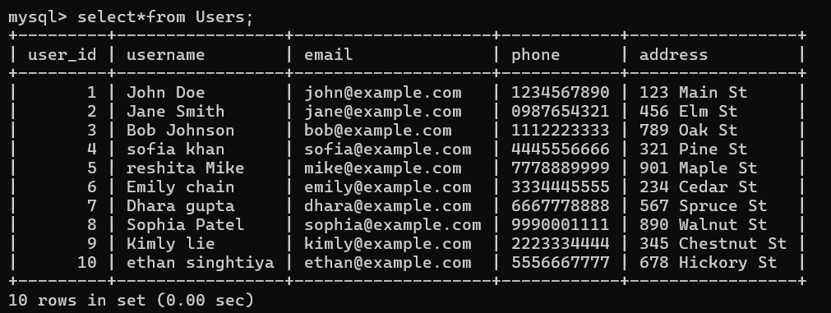

**Restaurants Table**

**Syntax:**

INSERT INTO Restaurants (name, location, rating, cuisine, contact)

VALUES

(‘Burger King’,’New York, NY’,4.5,’American’,’8663942493’),

(‘Taco Bell’,’Los Angeles, CA’,4.8,’Mexican’,’8008226235)’

(‘McDonalds’,’Chicago IL’,4.2,’American’,’8002446227’);

Output:

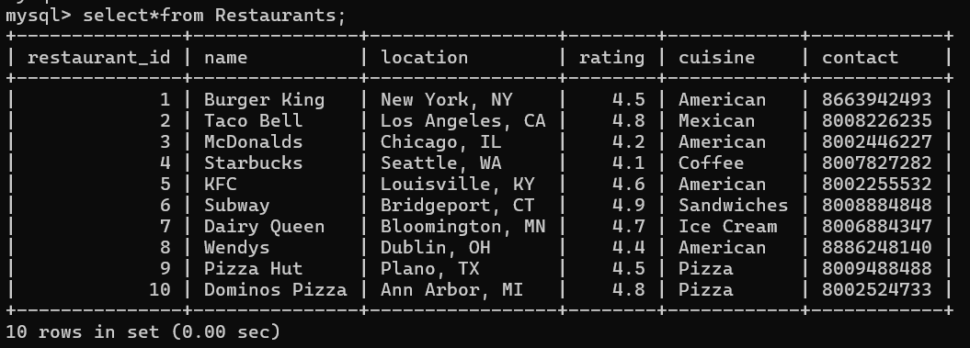

**Menu_Items Table**

**Syntax:**

INSERT INTO Menu_Items (restaurant_id, item_name, price, description) VALUES

(1, 'Margherita Pizza', 9.99, 'Classic cheese and tomato pizza'),

(1, 'Pepperoni Pizza', 12.99, 'Pepperoni pizza with mozzarella'),

(2, 'Salmon Sushi', 15.99, 'Fresh salmon nigiri sushi'),

(2, 'Tuna Sushi', 14.99, 'Fresh tuna nigiri sushi');

(3,’Crunchy Taco’,2.99,’Crunchy taco with beef and lettuce’),

(3,’Nachos BellGrande’,8.99,’Nachose with beef,cheese,and salsa’);

Output:

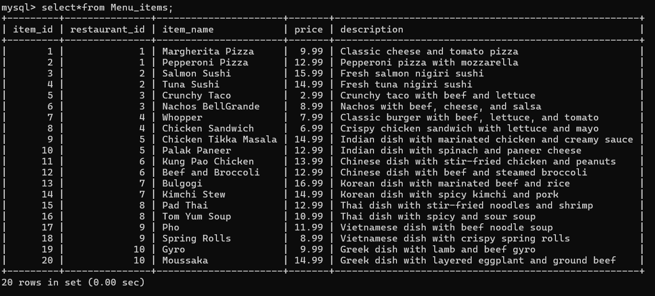

**Orders Table**

Syntax:

INSERT INTO Orders (user_id, restaurant_id, total_price, status)

VALUES(3, 3, 10.98, 'Completed'),

(1, 4, 20.94, 'Pending'),

(4, 5, 20.99, ’Cancelled’);

**Output:**

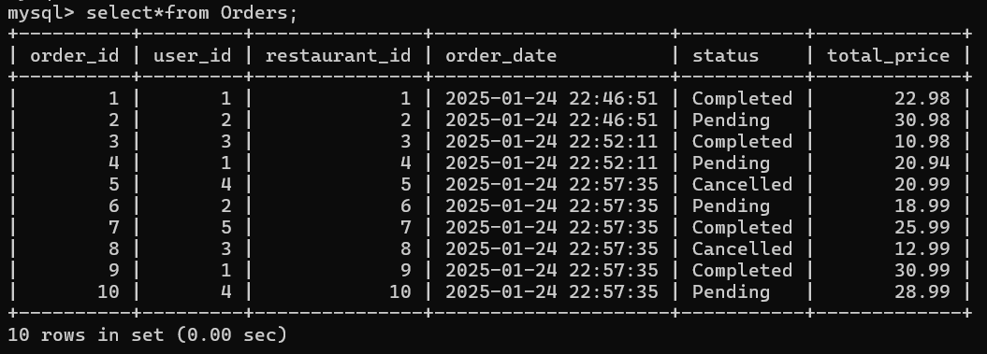

**Order_Items Table**

**Syntax:**

INSERT INTO Order_Items (order_id, item_id, quantity, price)

VALUES(1, 1, 1, 9.99),

(1, 2, 1, 12.99),

(2, 3, 2, 15.99),

Output:

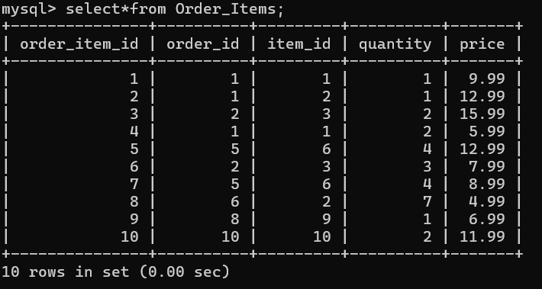

**Reviews Table**

Syntax:

INSERT INTO Reviews (user_id, restaurant_id, rating, comments)

VALUES (1, 1, 5, 'Amazing pizza! Highly recommend.'),

(2, 2, 4, 'Great sushi, but a bit pricey.');

(1, 1, 4, 'Great food and service');

(1, 4, 4, 'Love their coffe!');

**Output:**

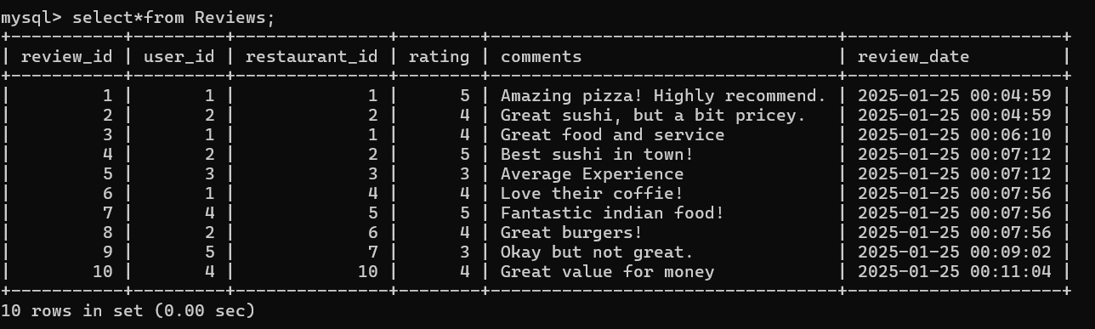

**Step 4: Writing Queries**

1. **Get all restaurants and their average rating:**

**Syntax:**

SELECT r.name, r.location, AVG(re.rating) AS average_rating

FROM Restaurants r

JOIN Reviews re ON r.restaurant_id = re.restaurant_id

GROUP BY r.restaurant_id;

**Output:**

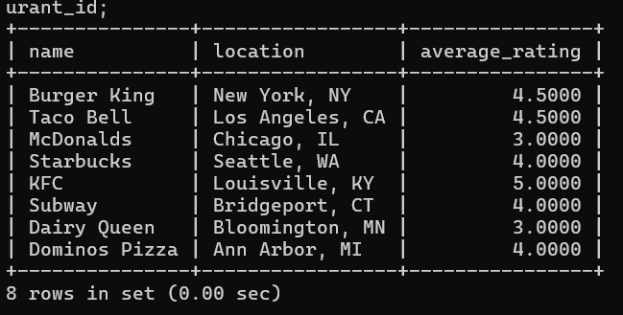

**2. Find all menu items of a restaurant:**

**Syntax:**

SELECT item_name, price, description

FROM Menu_Items

WHERE restaurant_id = 1;

Output:

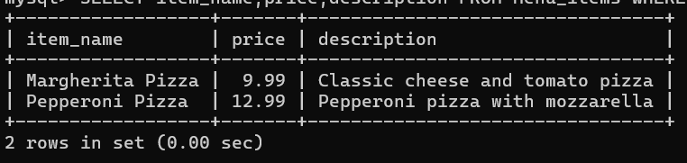

1. **Retrieve all orders by a user:**

**Syntax:**

SELECT Orders.order_id, Restaurants.name AS restaurant_name, Orders.total_price, Orders.status

FROM Orders

JOIN Restaurants ON Orders.restaurant_id = Restaurants.restaurant_id

WHERE Orders.user_id = 1;

Output:

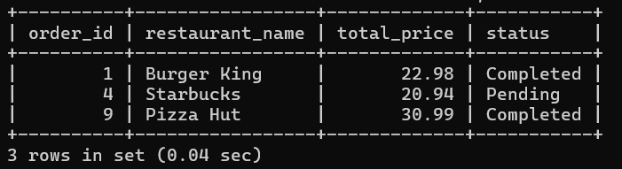

**4. Calculate total earnings for each restaurant:**

**Syntax:**

SELECT Restaurants.name, SUM(Orders.total_price) AS total_earnings

FROM Orders

JOIN Restaurants ON Orders.restaurant_id = Restaurants.restaurant_id

WHERE Orders.status = 'Completed'

GROUP BY Restaurants.restaurant_id;

**Output:**

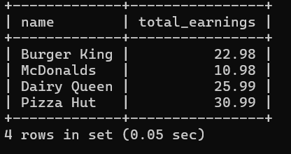

1. **Display all reviews for a restaurant:**

**Syntax:**

SELECT Users.username, Reviews.rating, Reviews.comments

FROM Reviews

JOIN Users ON Reviews.user_id = Users.user_id

WHERE restaurant_id = 2;

**Output:**

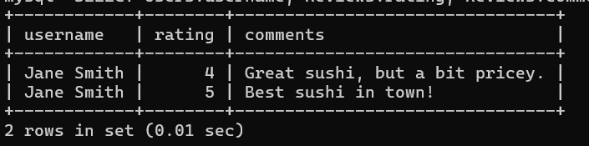

1. **Find the most expensive menu item in each restaurant**

**Syntax:**

SELECT r.name, mi.item_name, mi.price

FROM Restaurants r

JOIN Menu_Items mi ON r.restaurant_id = mi.restaurant_id

WHERE (r.restaurant_id, mi.price) IN (

SELECT restaurant_id, MAX(price)

FROM Menu_Items

GROUP BY restaurant_id

);

**Output:**

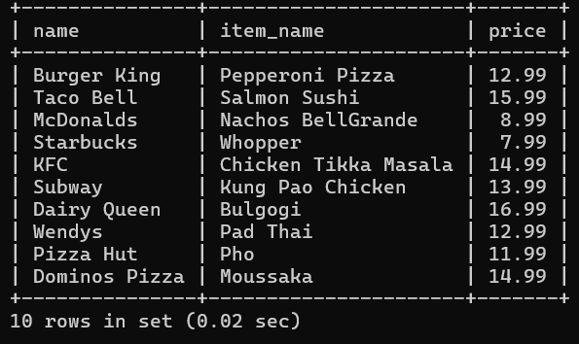

1. **Get all users who have ordered from a specific restaurant**

**Syntax:**

SELECT DISTINCT u.username

FROM Users u

JOIN Orders o ON u.user_id = o.user_id

WHERE o.restaurant_id = 1;

**Output:**

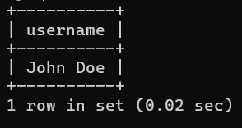

1. **Calculate the total number of orders for each user**

**Syntax:**

SELECT u.username, COUNT(o.order_id) AS total_orders

FROM Users u

JOIN Orders o ON u.user_id = o.user_id

GROUP BY u.user_id;

**Output:**

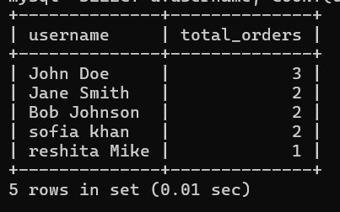

**9.Display all menu items that have been ordered by a specific user**

**Syntax:**

SELECT DISTINCT mi.item_name

FROM Menu_Items mi

JOIN Order_Items oi ON mi.item_id = oi.item_id

JOIN Orders o ON oi.order_id = o.order_id

JOIN Users u ON o.user_id = u.user_id

WHERE u.username = 'John Doe';

**Output:**

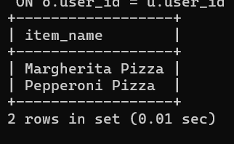

1. **Get the average rating for each cuisine**

**Syntax:**

SELECT r.cuisine, AVG(re.rating) AS average_rating

FROM Restaurants r

JOIN Reviews re ON r.restaurant_id = re.restaurant_id

GROUP BY r.cuisine;

**Output:**

